**Image Generation with stable diffusion**

Objective: To generate an image using stable diffusion model and document the exact prompt and seed used for reproducibility.

1. **Model Used:** 
   1. Model Name: RunDiffusion/Juggernaut-XL-v9
   2. Model Source: Hugging Face
   3. Model Type: Stable Diffusion XL (SDXL)
   4. Source: <https://huggingface.co/RunDiffusion/Juggernaut-XL-v9>
2. **Prompt Details:**
   1. Positive Prompt: "A modern cozy living room with clean white walls, a stylish green armchair near a wooden coffee table, a vibrant red flower vase placed on the table, minimalistic decor, photorealistic"
   2. Negative Prompt: “Dont include mugs, cups and a window”

These prompts were carefully designed to instruct the model on both what to include and what to exclude in the generated image. The positive prompt emphasizes aesthetic elements, realism and lighting. The negative prompt eliminates the use of unwanted objects.

1. **Seed for Reproducibility:**
   1. Seed Value: 42

A Fixed seed ensures that the same output image can be reproduced under the same conditions

1. **Inference Configuration:**
   1. Number of Inference Steps: 30 – For better quality of image
2. **Code:**

import torch

from diffusers import DiffusionPipeline

import random

import os

model_id = "RunDiffusion/Juggernaut-XL-v9"

pipe = DiffusionPipeline.from_pretrained(

    "RunDiffusion/Juggernaut-XL-v9",

    torch_dtype=torch.float16,      # Use float16 for speed and memory efficiency

    variant="fp16",                 # Required for many SDXL custom models

    use_safetensors=True            # Safer model loading format

)

pipe = pipe.to("cuda")

Prompt = "A modern cozy living room with clean white walls, a stylish green armchair near a wooden coffee table, a vibrant red flower vase placed on the table, minimalistic decor, photorealistic"

negative_prompt = "dont include mugs, cups and a window"

seed = 12345

generator = torch.Generator(device="cuda").manual_seed(seed)

image = pipe(

    prompt=Prompt,

    negative_prompt=negative_prompt,

    generator=generator,

    num_inference_steps=30,  # You can increase to 40 or 50 for better quality

    guidance_scale=7.5       # Common values: 7.0 to 8.5

).images[0]

output_path = "output{seed}.png"

image.save(output_path)

from IPython.display import Image, display

display(Image(filename=output_path))

**Generated Images:**

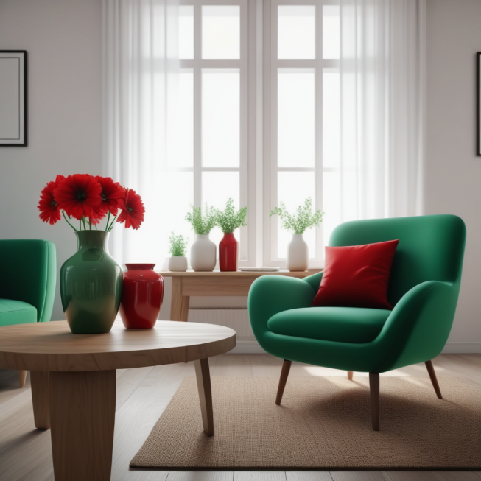

Before: Where only prompt was mentioned and no negative prompt

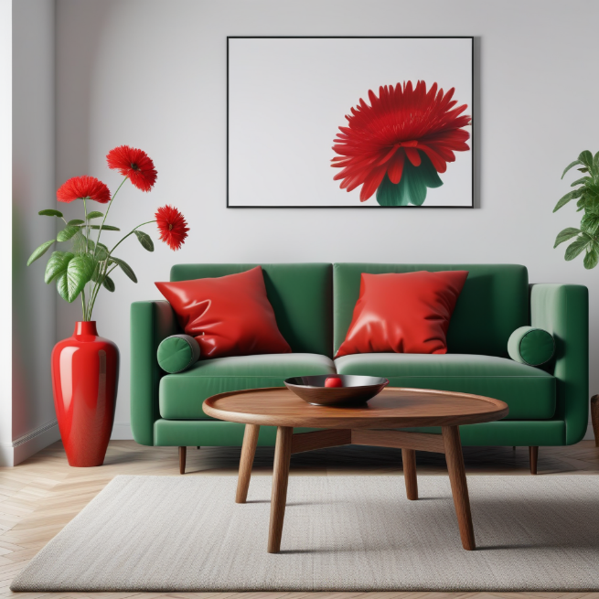

After: Where included negative prompt where windows and mugs were removed.